Photos—Russia-Georgia War, 2008
Russian
1. 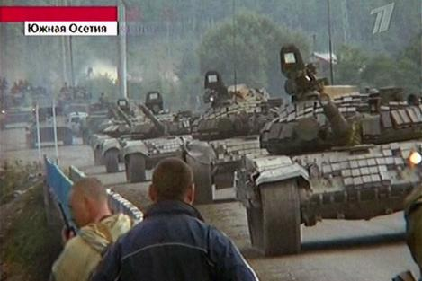
Russian tanks surge into South Ossetia to protect Russia's citizens and peacekeepers after the Georgian Army attacked the breakaway region this week, killing over 1,400 civilians. Georgia has claimed South Ossetia as its territory since the breakup of the Soviet Union in 1992, while South Ossetian separatists have sought independence and perhaps union with North Ossetian compatriots in Russia.
2. Russian soldier funeral
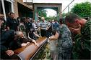
3. 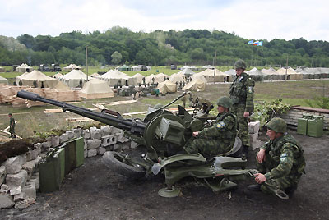
4. 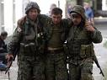
5. Russian veteran salutes soldiers
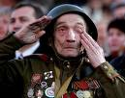
6. 
7. 

Georgia
- 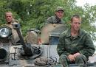

2. 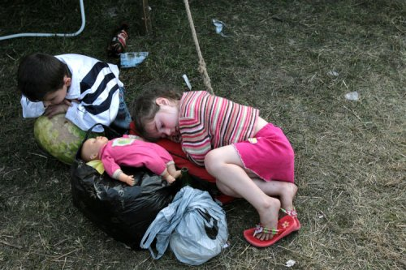
3. 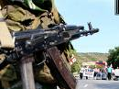
4. 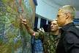
5. 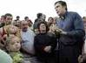\

6. 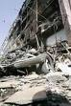
7. 

