Readers like stories about problems more when they also include possible solutions
Shown a news story, research subjects found versions that discussed possible solutions consistently more engaging.
By CAROLINE O’DONOVAN @ceodonovan June 2, 2014, 8 a.m.
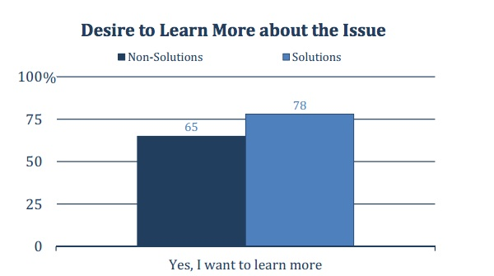
If you tell someone about a problem, it’s best to offer up a solution.
True in real life, and — according to a new study from the Engaging News Project at the University of Texas — true in journalism. Researcher Alex Curry (formerly a writer for Governor Arnold Schwarzenegger!) conducted a survey of 1,500 individuals aimed at learning how people react to solutions journalism, resulting in a report called “The Power of Solutions Journalism,” coauthored with Keith Hammonds.
Hammonds is the chief operating officer at the Solutions Journalism Network, which partnered with the Engaging News Project on this study. The network was founded by two New York Times columnists,David Bornstein and Tina Rosenberg, along with authorCourtney Martin. They wanted to address what they saw as a polarized, limited, and reductive news ecosystem. The idea is to present a problem side by side with a possible solution in hopes of delivering a more informative and engaging news product. Bornstein and Rosenberg co-author the Fixes column at The New York Times in which they “examine creative initiatives that can tell us about the difference between success and failure.” The network currently has 12 publisher partners, including The Seattle Times, the Deseret News, McClatchy papers, and The San Francisco Chronicle.
“What they’re doing fits well with the mission of the Engaging News Project, which is to find commercial benefits and democratic benefits in online news,” Curry says. “We were intrigued by the idea of Solutions Journalism because their anecdotal evidence said when people see solutions based articles, there’s a better reaction from them. They’re more excited about the articles — they say they want to read more about this.”
For the study, Solutions Journalism prepared three different news articles based on Fixes column stories, with two versions of each — one a bare-bones article, the other identical but with added solutions content. For example, the solutions version of a story about a severe lack of clothing in India includes a few paragraphs about an organization called Goonj that supports a Cloth for Work program that’s not mentioned in the regular version. A story about homelessness in New York only mentions a housing program called Home to Stay in the solutions version. Another, about childhood trauma, introduces Susan Cole’s Trauma and Learning Policy Initiative as a potential solution only in the second version.
After reading one of these six possible articles, respondents answered a survey about what they’d read. Did the article seem different from typical news articles? Do you feel more interested in the issue, or better informed? Have you gained knowledge from reading the article? Was your opinion influenced? Were you inspired? Do you feel there’s a way that you could contribute to a solution?
The results were somewhat surprising. Across all 16 measures, those who had read the solutions journalism article felt more satisfied, Curry found. “Often, doing research, you don’t get results where something works so well,” he said.
Anecdotal evidence from experimental partnerships conducted by the Solutions Journalism Network suggested the findings would be positive — that readers would report feeling more engaged, informed, and optimistic after reading a solutions story. “It’s very clear that people engage differently with these stories than they do with regular stories about problems,” says Hammonds. “The quality of the comments on the stories is much different. The discourse changes from antagonistic, black-and-white, he-said she-said to something that’s much more constructive.”
Still, a perfect score is somewhat unusual. Curry did say that about half the sample was excluded from these results — only 755 of the 1,500 who took the survey were counted — because the other half failed to pass a manipulation check. In this case, there was a question at the end of the survey intended to determine whether the respondent had actually read the article and responded to the survey with care. But, he says, “if you take all the people in the survey, those who failed and passed, you still have significant results for several of the variables.”
For the Solutions Journalism Network, the study is a welcome confirmation. “It reinforces our worldview,” Hammonds says. Impact studies like these are important as they expand their network and persuade more news outlets to produce solutions journalism. To that end, it will be especially helpful to be able to say that solutions journalism might lead to more sharing on social media, as well as to greater loyalty.
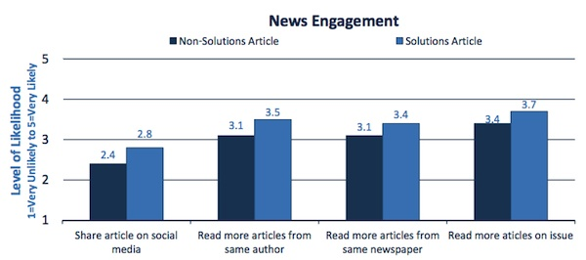
“We are intrigued by the finding that people seem to want to share these stories more, and want to create conversation around them,” Hammonds says. “So we may build on that in the way we strategize with our papers.”
As with most research, this study begets the desire for more research. Does that positive reaction from readers lead to action? Or is it simply because it’s satisfying to read what feels like a happy ending? “What we measure here is not behavior but behavioral intentions — which are related to actual behavior, but that’s as far as we can go,” says Curry.
The Solutions Journalism Network is interested in learning more. For example, Hammonds said they’re curious about whether the phrasing of a headline can affect how readers feel when they walk away from a piece. They also wonder whether the impact might not change depending on where the solution is introduced in the arc of a story. But primarily, they’re interested in tracking how news engagement translates to real-life engagement. For example, does coverage of public education lead to readers joining the school board or the PTA? They plan on working to answer questions like these via their Education Lab project, a year-long partnership with The Seattle Times. But even if there isn’t a direct correlation between social action and solutions journalism, Hammonds says the study suggests it’s capable of shifting mindsets.
“Being introduced to the possibility of change could effect you as a world citizen,” he says. “It effects the way you think about other big problems closer to home — the poor in your city, the poor in America. That these are not, in fact, intractable.”

